1. Create the tables below in the database. Use foreign keys and primary keys as required.
   1. Create a table called as student with the following columns student_id, first_name, last_name ,birthdate , department_id ,address_id .
   2. Create Address table with following columns address_id , street_address, city, State, postal_code
   3. Create department table department_id, department name. Make sure you are using the right data type against all the columns.

CREATE TABLE department(

department_id INT PRIMARY KEY,

department_name VARCHAR(100) NOT NULL

);

CREATE TABLE address(

address_id INT PRIMARY KEY,

street_address VARCHAR(150) NOT NULL,

city VARCHAR(100) NOT NULL,

state CHAR(2) NOT NULL,

postal_code VARCHAR(10) NOT NULL

);

CREATE TABLE student(

student_id INT PRIMARY KEY,

first_name VARCHAR(50) NOT NULL,

last_name VARCHAR(50) NOT NULL,

birthdate DATE NOT NULL,

department_id INT,

address_id INT,

FOREIGN KEY (department_id) REFERENCES department(department_id),

FOREIGN KEY (address_id) REFERENCES address(address_id)

);



1. Use Sample data from [sampledata.txt](https://hs2solutions-my.sharepoint.com/:t:/g/personal/iqbal_sarkar_bounteous_com/ET8VdCEdjTJNoaWCrFPFxfwBq9bpLp9HkT7ycwnltym8qA?e=xTKw8M) to insert data into the database

INSERT INTO department VALUES

(1, 'Computer Science'),

(2, 'Mechanical Engineering'),

(3, 'Electrical Engineering'),

(4, 'Civil Engineering'),

(5, 'Mathematics'),

(6, 'Biology');

INSERT INTO address VALUES

(1, '123 Elm St', 'Springfield', 'IL', '62701'),

(2, '456 Oak St', 'Decatur', 'IL', '62521'),

(3, '789 Pine St', 'Champaign', 'IL', '61820'),

(4, '102 Birch Rd', 'Peoria', 'IL', '61602'),

(5, '205 Cedar Ave', 'Chicago', 'IL', '60601'),

(6, '310 Maple Dr', 'Urbana', 'IL', '61801'),

(7, '415 Oak Blvd', 'Champaign', 'IL', '61821'),

(8, '520 Pine Rd', 'Carbondale', 'IL', '62901');

INSERT INTO student VALUES

(1, 'John', 'Doe', '1995-04-15', 1, 1),

(2, 'Jane', 'Smith', '1996-07-22', 2, 2),

(3, 'Alice', 'Johnson', '1994-11-30', 3, 3),

(4, 'Michael', 'Brown', '1997-02-19', 4, 4),

(5, 'Sophia', 'Davis', '1998-01-05', 5, 5),

(6, 'Daniel', 'Wilson', '1995-06-10', 6, 6),

(7, 'Olivia', 'Martinez', '1997-11-25', 1, 7),

(8, 'Ethan', 'Miller', '1996-03-30', 2, 8);



1. Write a query to find the total number of students.

SELECT COUNT(*) AS TOTAL_STUDENTS FROM STUDENT;

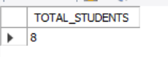

1. Write a query to find which department john belongs to.

SELECT FIRST_NAME, DEPARTMENT_NAME FROM STUDENT INNER JOIN DEPARTMENT

ON STUDENT.DEPARTMENT_ID = DEPARTMENT.DEPARTMENT_ID WHERE FIRST_NAME = "John";

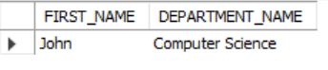

1. List All Departments with Their Number of Students (Including Departments with No Students)

SELECT D.DEPARTMENT_NAME, COUNT(S.STUDENT_ID) AS TOTAL_STUDENTS

FROM DEPARTMENT D LEFT JOIN STUDENT S

ON D.DEPARTMENT_ID = S.DEPARTMENT_ID GROUP BY D.DEPARTMENT_NAME;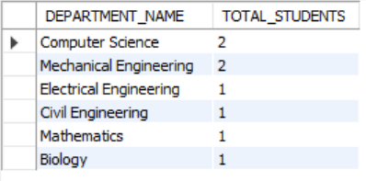

1. Select all students with their department and address.

SELECT S.FIRST_NAME, D.DEPARTMENT_NAME, A.STREET_ADDRESS

FROM DEPARTMENT D INNER JOIN STUDENT S INNER JOIN ADDRESS A

ON D.DEPARTMENT_ID = S.DEPARTMENT_ID AND S.ADDRESS_ID = A.ADDRESS_ID;

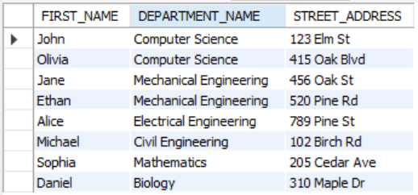

1. Find all students who are in the 'Computer Science' department

SELECT DEPARTMENT_NAME, FIRST_NAME, LAST_NAME FROM STUDENT INNER JOIN DEPARTMENT

ON STUDENT.DEPARTMENT_ID = DEPARTMENT.DEPARTMENT_ID

WHERE DEPARTMENT_NAME = "Computer Science";

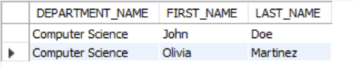

1. Update Jane’s city name to New York.

UPDATE ADDRESS SET CITY = "New York" WHERE ADDRESS_ID =

(SELECT ADDRESS_ID FROM STUDENT WHERE FIRST_NAME = "Jane");



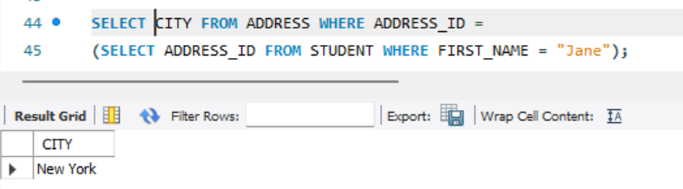

1. Delete a student from the student table.

DELETE FROM STUDENT WHERE STUDENT_ID = 8;



1. Select all students with their department and address in New York.

SELECT S.FIRST_NAME, D.DEPARTMENT_NAME, A.CITY

FROM DEPARTMENT D INNER JOIN STUDENT S INNER JOIN ADDRESS A

ON D.DEPARTMENT_ID = S.DEPARTMENT_ID AND S.ADDRESS_ID = A.ADDRESS_ID

WHERE A.CITY = "New York";

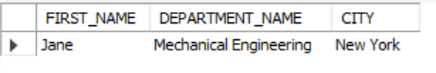

1. Count how many students are in each department

SELECT D.DEPARTMENT_NAME, COUNT(S.STUDENT_ID) AS NUMBER_OF_STUDENTS

FROM DEPARTMENT D LEFT JOIN STUDENT S ON D.DEPARTMENT_ID = S.DEPARTMENT_ID

GROUP BY D.DEPARTMENT_NAME;

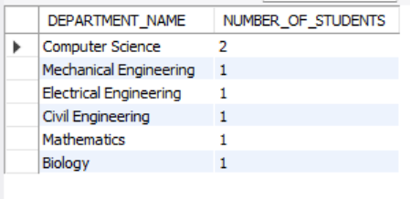

1. Find students who live in 'Springfield'

SELECT S.FIRST_NAME, A.CITY FROM STUDENT S INNER JOIN ADDRESS A

ON S.ADDRESS_ID = A.ADDRESS_ID WHERE A.CITY = "Springfield";

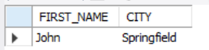

1. Select students whose birthday falls in February

SELECT FIRST_NAME, LAST_NAME, DATE_FORMAT(BIRTHDATE, '%b') as MONTH

FROM STUDENT WHERE MONTH(BIRTHDATE) = 2;

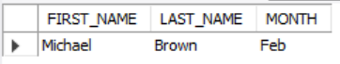

1. Get the department and address details for a specific student, example john

SELECT S.FIRST_NAME, D.DEPARTMENT_NAME, A.STREET_ADDRESS

FROM DEPARTMENT D INNER JOIN STUDENT S INNER JOIN ADDRESS A

ON D.DEPARTMENT_ID = S.DEPARTMENT_ID AND S.ADDRESS_ID = A.ADDRESS_ID

WHERE S.FIRST_NAME = "John"; 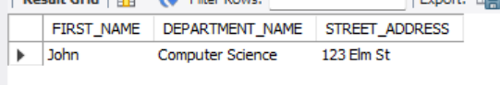

1. Find all students who are born within 1995 to 1998

SELECT FIRST_NAME, LAST_NAME, BIRTHDATE FROM STUDENT

WHERE YEAR(BIRTHDATE)>=1995 AND YEAR(BIRTHDATE)<=1998;

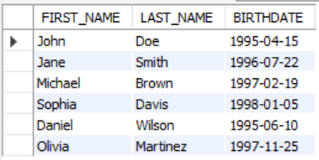

1. List all students and their corresponding department names, sorted by department

SELECT FIRST_NAME, LAST_NAME, DEPARTMENT_NAME FROM STUDENT INNER JOIN DEPARTMENT

ON STUDENT.DEPARTMENT_ID = DEPARTMENT.DEPARTMENT_ID ORDER BY DEPARTMENT_NAME;

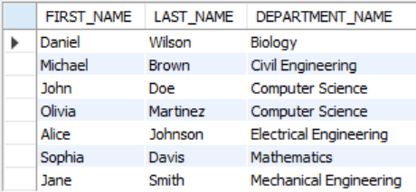

1. Find the number of students in each department who are living in 'Champaign'

SELECT DEPARTMENT_NAME, NUMBER_OF_STUDENTS, CITY FROM

(SELECT S.ADDRESS_ID, D.DEPARTMENT_NAME, COUNT(S.STUDENT_ID) AS NUMBER_OF_STUDENTS

FROM DEPARTMENT D LEFT JOIN STUDENT S ON D.DEPARTMENT_ID = S.DEPARTMENT_ID

GROUP BY D.DEPARTMENT_NAME, S.ADDRESS_ID) AS T1 INNER JOIN ADDRESS A

ON T1.ADDRESS_ID = A.ADDRESS_ID WHERE CITY = "Champaign";

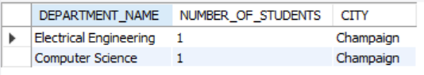

1. Retrieve the names of students who live on 'Pine' street

SELECT S.FIRST_NAME, A.STREET_ADDRESS FROM STUDENT S INNER JOIN ADDRESS A

ON S.ADDRESS_ID = A.ADDRESS_ID WHERE A.STREET_ADDRESS LIKE "%pine%";

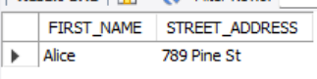

1. Update the department of a student with student_id = 6 to 'Mechanical Engineering'

UPDATE DEPARTMENT SET DEPARTMENT_NAME = "Mechanical Engineering" WHERE DEPARTMENT_ID =

(SELECT DEPARTMENT_ID FROM STUDENT WHERE STUDENT_ID = 6);

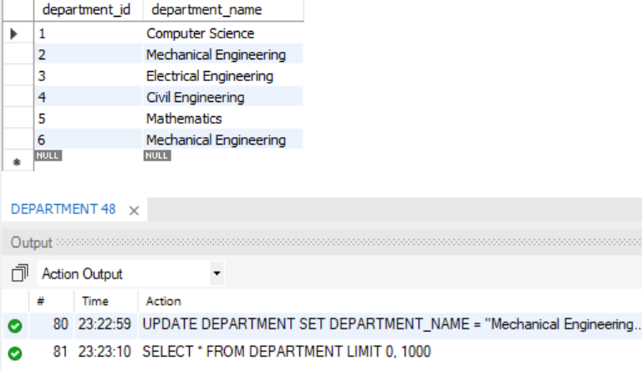

1. Find the student(s) who live in the city 'Chicago' and are in the 'Mathematics' department
2. List all students who have an address in 'Urbana' or 'Peoria'
3. Find the student with the highest student_id
4. Find all students who are not in the 'Computer Science' department
5. Count the total number of addresses in the 'Champaign' city
6. Find the name of the student who lives at '520 Pine Rd'
7. Get the average age of students in the 'Electrical Engineering' department
8. List the students, their department, and the city where they live, but only for those in departments starting with 'M'
9. Delete a student from the 'Mechanical Engineering' department

Download [order.sql](https://hs2solutions-my.sharepoint.com/:u:/g/personal/iqbal_sarkar_bounteous_com/ERszToxU3wJNo1HXV0zhiNgBMx8PQdMY207902wVY8Mnhg?e=qqdFSF)

Open PG Admin and open query tool and select any database of your choice.

Click on “Open file” and select [order.sql](https://hs2solutions-my.sharepoint.com/:u:/g/personal/iqbal_sarkar_bounteous_com/ERszToxU3wJNo1HXV0zhiNgBMx8PQdMY207902wVY8Mnhg?e=qqdFSF) from your device and execute it.

Questions:

1. Retrieve All Orders with Their Customer Details and Current Status
2. Get the Total Value of Orders for a Given Customer in a Specific Time Period
3. Find the Most Expensive Order by Customer
4. Find the Total Revenue for Each Product Based on Orders
5. Write a query to retrieve the order ID, customer ID, and the total amount of each order. If the total amount is null, display '0.00' instead.
6. Retrieve the Order History of a Specific Customer Along with Product Details
7. Get the Average Order Value Per Customer in the Last 30 Days.
8. Get the Top 5 Products with the Highest Number of Orders.
9. Get the Customers Who Have Not Placed Any Orders in the Last 60 Days
10. List the Orders with Products Ordered More Than Once, Sorted by Order Date
11. Retrieve the Number of Orders and Total Revenue for Each Status
12. Find Customers Who Have Ordered More Than a Specific Product (e.g., "Laptop")
13. Find the Products That Have Never Been Ordered
14. Get the Total Quantity of Products Ordered in the Last 7 Days
15. Create a view named product_details that includes all columns from the product table.
16. Create a view named order_summary that includes the order_id, customer_id, order_date, total_amount, and status_name (from the status table) for each order.